TEAM ID: PNT2022TMID08163

PROJECT NAME: DemandEst - AI powered Food DemandForecaster

# Team Leader

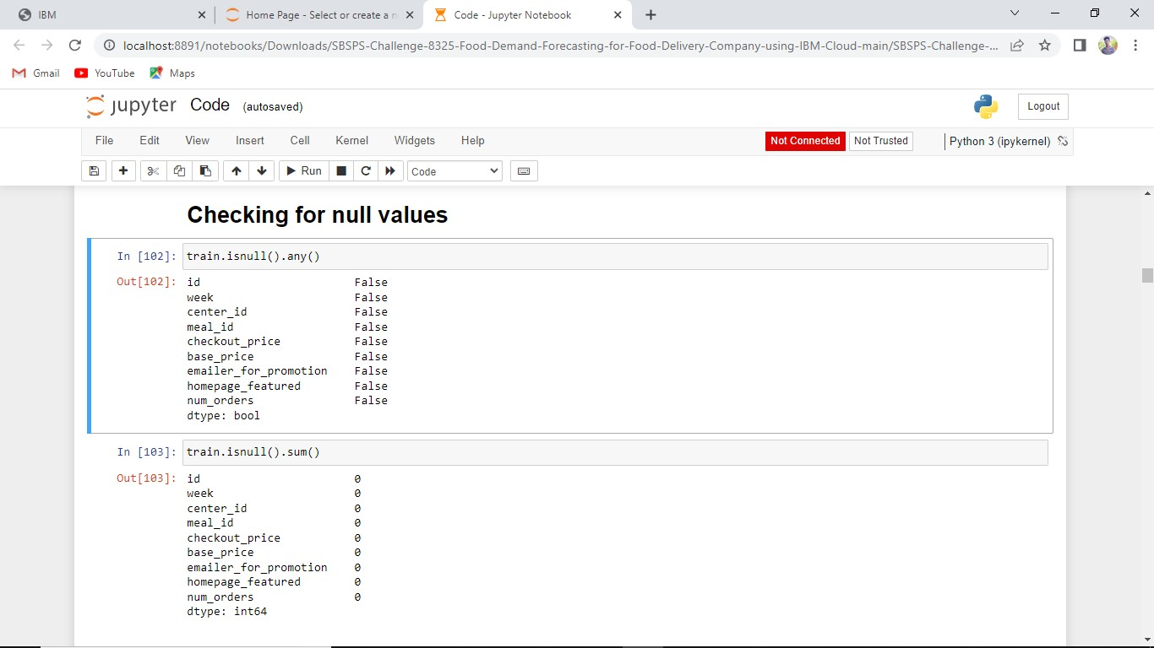

# Team Member 1



# Team Member 1



# Team Member 2



# Team Member 3

